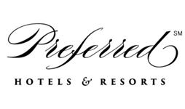

EMEA-Market

Update- Q1 2021

LEISURE TRAVEL

United Kingdom

- Over 31mil people have now been vaccinated against COVID in the UK. Over 5mil of these have also already received their second dose

- Consumer confidence since the start of the year has increased and that has reflected in the number of enquiries received during Q1. Destinations in demand included: Maldives, Dubai, Greece, Spain, California. Most booking requests received have been for late summer 2021 / beginning of 2022

- At present 17th May is still set to be the date when foreign travel will be allowed again, using the “traffic light” system. Anyone travelling will not be to leave the UK an online Passenger Locator Form (PLF) is completed and a negative test result is provided– which includes rapid antigen or lateral flow tests.
From low-risk countries – or regions – on the green list, there will be no need to quarantine on return, but an expensive pre-booked post-arrival PCR test will still be needed. This is likely to cost upwards of £100. It must be taken on the day of arrival (“day zero”), the day after or the following day (“day two”).
For a family of four for example the cost of the necessary tests at either end could add £500 on top of the cost of the holiday. The government says it will work with the travel industry and private testing providers ahead of international travel reopening to see how we can further reduce the cost of travel.
For regions in amber, the traveller must self-isolate at home for 10 days and pre-book two post-arrival tests – with the option to take an extra test after five days and leave quarantine.
In time, people who have completed a course of vaccination may be able to avoid the need to quarantine on return from “amber” nations.
The assumption at present is that the current red list – with 11 nights of mandatory hotel quarantine at a cost for a single traveller of £1,750 – will continue.

- Most of Europe is currently in the “red” list with exception of Malta and Portugal which are in “green” and Spain which is in “amber”. At present other “green” countries include: USA, Canada, Mexico, Maldives, Seychelles, Israel

- American Express UK have confirmed that most of their travel team have now returned to their role, after spending the most part of the last 12 months supporting alternative areas of the business, whilst they waited for travel demand to pick up again. This indicates a growth in the number of travel requests received

- Traveller Made announces that their physical annual event “The Essence of Luxury” due to take place in April in Marbella has been cancelled and replaced with a virtual show scheduled for the first week of June 2021

Contact for this market based in London, United Kingdom
Isabella Moroni: imoroni@preferredhotels.com

Central Europe
The German economy has been hit hard, because the economy is depending on the export market. Currently (March 2021), there is a growth expected by 3,1% for 2021, but might get reduced again because of the third Covid 19 wave, the ongoing lockdown in Central Europe until mid of May and the very slow vaccination process in the European Union.
The consumer behavior is an important indicator to see, how the consumer are willing to invest or to spend money.
In times of crisis the level is normally shrinking slightly, but has been reached a new record of over -23% compared to last year (average level is between +7-10%).
Due to the relaxation of the restrictions in the European Union and Schengen area, the behavior and climate has been increase slightly and is showing -18.6% for June and only -1.7% in August / September.
The second Covid Wave made a more pessimistic outlook for October with -3.1%, which increased furthermore in January to -7.3%, -15.5% in February, -12.7% in March. This is a result of the further extensions of lockdowns and the missing opportunity to travel. The Outlook for April with -6.2% looks more optimistically, but as long as the vaccination process is running so slowly and in case of further extended lockdowns the climate index won’t become more positively, which will effect the willingness to travel as well.
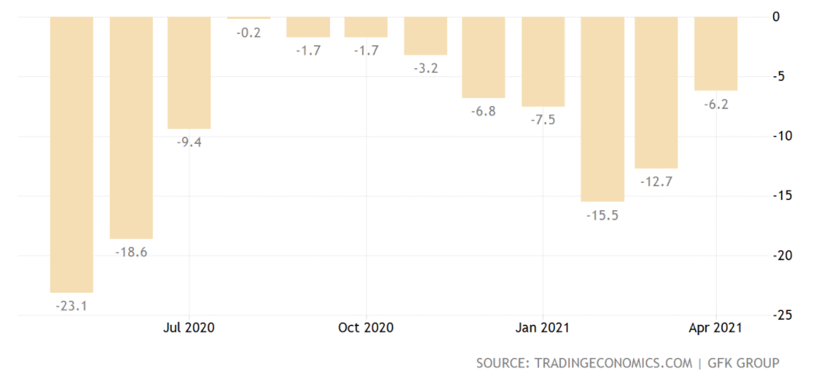

Trends:
- Tour Operator (TUI / airtour, FTI, DERTour / DERTour Deluxe and others) are offering very flexible CXL conditions, but are all running on a very low level on production
- Local / regional offers through OTA’s are increasing
- Residence business is increasing
- Upcoming spring / summer destinations, but depends if countries will become are No-Risk Covid Country: Italy, Spain, Portugal, Southern France, Croatia, Netherlands, Scandinavia

Recommendations:
- Preparing Local Leisure Packages, which are available through your website, our website and GDS: it should / could include Parking and shows the hygiene procedure at your hotel
- Double check all iPrefer opportunities through Preferred Hotels & Resorts
- Be flexible in CXL and rate, but always look on rate parity
- Use all social media channels with local and regional high end travel agencies
- Offering higher percentage of commission to support high end travel agencies

Contact for this market all based in Munich, Germany
Stephan Brauer (Leisure | Corporate) SBrauer@preferredhotels.com

Russia, CIS, Ukraine, Baltics
General Market and Tourism trends / Leisure Travel and Consumer Behavior:
Overall economic and consumer trends:
As per the World’s Bank report on Russia Russian economic growth was -4 percent in 2020, a less severe contraction than the forecast of September 2020. The revision reflects the better-than-anticipated economic performance in 2021. Consumer and business confidence are expected to improve assuming a vaccine deemed safe and effective is rolled out; this would pave the way for a gradual rebound at 2.6 and 3.0 percent in 2021 and 2022, respectively. Daily new COVID-19 cases in Russia were at approximately 8.6 thousand on April 14, 2021, marking a gradual decrease compared to the end of the previous year. Russia wants the majority of its citizens to be vaccinated against the novel coronavirus, SARS-CoV-2, by the autumn of 2021 by means of one of three vaccines which have been approved by the government. Different restrictions and travel bans are valid for other CIS countries and Baltic States, for example international travel to/from Belarus, Ukraine, Baltic States are not forbidden. Thus, as of April 7, 2021 the state of emergency has ended in Latvia, but most epidemiological safety rules remain in place. Entry to Latvia from European Union Member States and the European Economic Area Member States, the Swiss Confederation is permitted for "urgent and essential" reasons only. These are defined as: work, training, studies, family reunion, in order to receive medical services, transit, accompanying a minor, return to one’s permanent place of residence, attending a funeral. From March 17 international passenger flights to and from third countries are permitted, including flights organized by tour operators for purposes of tourism and recreation. On arrival in Latvia from third countries, there is an obligation to perform a repeat Covid-19 test, the so-called “quick test”. Arriving from other countries 10 days quarantine is still necessary. Regarding Belarus nonresident foreign nationals may enter the country by air upon presenting a negative PCR test taken no more than 72 hours prior to arrival. Travelers transiting the country in less than 24 hours will not be subject to self-isolation or the requirement to produce the results of a recent COVID-19 test making Belarus and its capital Minsk a popular transient hub for international flights to Montenegro, Turkey, Croatia open for international travel for citizens from Russia and CIS as well.

Leisure Travel
- Russian citizens arriving in the Russian Federation on international flights must fill in a special form on the Unified Public Services Portal (www.gosuslugi.ru) before departure, and then, within three days from their arrival in the Russian Federation, upload the results of the Covid-19 PCR test to the previously filled in form; while waiting for the results of the Covid-19 PCR test, passengers must self-isolate at their place of residence/temporary stay. During the flight, passengers must also fill in the form provided by the flight attendants.
- International travel following the restoration of scheduled air traffic between the Russian Federation is possible to the United Kingdom, Tanzania, Turkey, Switzerland, the UAE, Maldives, Egypt, Belarus, Kazakhstan, Kyrgyzstan, the Republic of Korea, Cuba, Serbia, Japan, Seychelles, Ethiopia, Vietnam, India, Qatar, Finland, Azerbaijan, Armenia, Greece, Singapore, Venezuela, Germany, Syria, Tajikistan, Uzbekistan and Sri Lanka. However, flights to the United Kingdom were suspended until April 16 in a bid to minimize risks of imports of a new coronavirus strain.
- As per TASS news agency Russia restricts air service with Turkey and suspends flights to Tanzania from Thursday, April 15, 2021 to June 1 in line with the decision of the federal anti-coronavirus crisis center. Thus, all cargo, passenger and chartered flights and nearly all regular flights between Russia and Turkey will be suspended, with only two regular flights between Moscow and Istanbul being performed a week by a Russian air company and two such flights - by a Turkish air carrier. Russia’s flagship air carrier Aeroflot already said it would continue regular flights to Istanbul twice a week. According to Russian Deputy Prime Minister Tatiana Golikova, air service with Tanzania and Turkey will be resumed as soon as the coronavirus situation in those countries stabilizes. This is not the first case of repeated suspension of air service with foreign countries amid the pandemic. Golikova noted that Russian nationals staying in Turkey would be able to return home by chartered flights. Regular flights to Turkey were performed by eight Russian air carriers, namely Aeroflot, Pobeda, Rossiya, S7, Nordwind, UTair (the only air company flying not from Moscow and St. Petersburg, but from Grozny), Azur Air, and Ural Airlines. Flights from Turkey to Russia were operated by Turkish Airlines, Corendon Airlines, and Pegasus Airlines. By now, Aeroflot, Pobeda and S7 have already drawn schedules of return flights. Most of the air companies have already pledged to return money for cancelled flights without any penalties. Flights to Tanzania were performed by UTair and Azur Air. According to the President of the Russian Union of the Travel Industry Andrei Ignatyev around 30,000 Russian tourists were vacationing in Turkey, with this number including only those who had vouchers from travel companies. Several hundreds of Russian tourists, according to experts, are staying on Zanzibar. However, since there is no ban on travel to Turkey.
- There are currently travel restrictions imposed in Russia due to the Covid-19 pandemic. At the moment, you can only travel to Russia if you are a citizen of UK, Germany (since 1/04/21), Greece, Switzerland, South Korea, Turkey, Serbia, Japan, United Saudi Emirate, Egypt, Cuba and some other countries. All you need is a tourist visa (for UK and Swiss nationals, who can obtain it following the standard procedure) and a negative Covid-19 test made not earlier than 48 hours before your arrival to Russia. If you are a national of another country, there are still some ways to travel but they are very limited. The travel ban to Russia for all other countries will be lifted gradually, country by country. First for the EU countries (probably until September 2021) and then for the USA (probably October - November 2021).
- Russian travellers are not only keen to travel within Russia during pandemic times in 2020-2021 but also to explore more exotic destinations. Once Russia lifted its travel ban to the UAE on 3 September, air tickets to Dubai started to pick up. The increase was most noticeable from the beginning of November and reached 2019 levels in January 2021. Over the years, the UAE has been an increasingly popular destination for Russians, particularly during their cold winter season. Looking at arrivals to the destination for the last quarter of 2020 the ticketing data shows that Russians are enjoying longer stays in Dubai. The average number of nights spent in Dubai almost doubled, going from an average of 4.7 nights in Q4 2019 to 8.2 nights in Q4 (see picture 1)
- A newcomer to the affluent Russian traveller market is the Maldives. The Maldives has become the hottest destination for Russian travellers at the start of 2021. As per bookings issued by 20 January for travel up to April 21, tickets to the Maldives were advancing the fastest, ahead by +44%, while tickets for total international travel lagged by 87% when compared to 2020 levels. “It is with great contentment I note that the Russian market is now the top market in terms of arrivals to the destination since we have reopened our borders in July 2020. Our initial strategies for the market had to be completely shifted due to the pandemic. We altered our focus to utilize online & digital platforms to maintain the destination presence and partnered with some of the leading Russian tourism-related organizations, operators, travel agents and travel TV channels in order to spread knowledge about our destination to boost arrivals from Russia,” says Mr Thoyyib Mohamed, Managing Director of Visit Maldives.
Picture 1
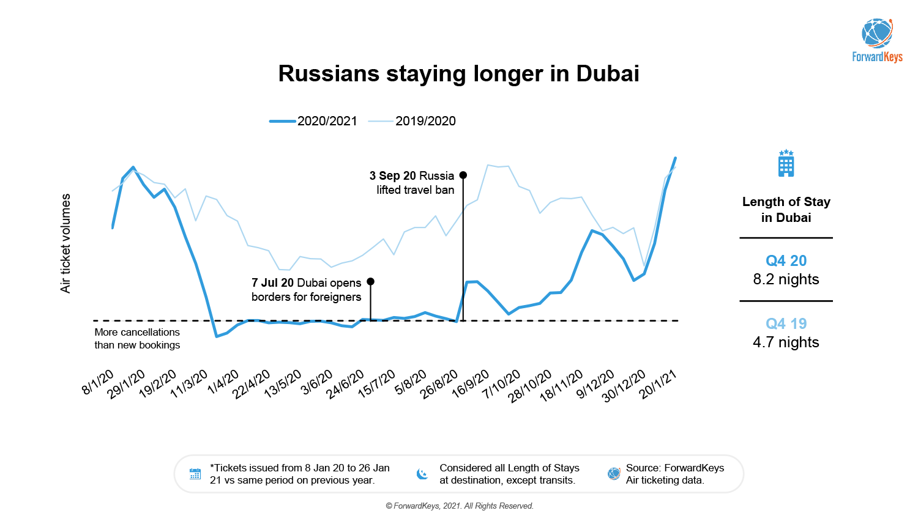
- Among the other positive news for the upcoming travel season is the expected opening of Greece, Cyprus, Israel for international travel. Thus, the Embassy of Greece in Russia can now issue Schengen visas to all persons who want to visit the country, Greek Ambassador to Russia Ekaterini Nassika has recently announced. The announcement follows a previous statement of Greece’s Tourism Minister, Harry Theocharis, that the country would begin welcoming Russian tourists who present a negative result of the Coronavirus test, or vaccination certificates, from May 14, SchengenVisaInfo.com reports. Such an announcement has already led to an increase in hotel booking rates and rising hopes for many tourists who plan to visit the Hellenic Republic. Even though some countries do not accept vaccines that are not authorized by the World Health Organization or the European Medicine Agency, such as those coming from Russia and China, authorities in Athens recognized Russia’s vaccine against the Coronavirus, which is named Sputnik V. Greece’s Tourism Minister also highlighted that the vaccination is not obligatory for tourists; however, this process would save them from many formalities.
- Tour operating programs offered by international hotel groups in the Russian market are gaining in popularity really fast due to the clients becoming more sensitive to the rate parity issues, and small tour operators striving to earn more profits and not sharing the profits with DMCs. The net rate programs such as the one elaborated by Preferred Hotel Group under the brand of 20 by Preferred will attract more participating small tour operators working in the luxury sector through 2021.

Contact for the markets of Russia, CIS, Ukraine, Baltics is Elvira Tarasenko, Director of Global Sales: etarasenko@preferredhotels.com

CORPORATE/BUSINESS TRAVEL

UK- Corporate & Entertainment
1 USD = 0.73 GBP
- In Q1 2021 the UK’s Covid19 vaccination efforts have been very successful and at the end of Q1 over 5 million people have received their vaccine already. Though the UK has a strategy of total country vaccination by July 2021, the appetite to return to travel was very mixed and that buyers stated they would not be forcing people to travel but will be providing the information they need to make that decision.
- Business Travel in Q1 however remained very slow in uptake and companies took the time in Q1 to re-organise their travel policies and administrative needs that will take place when business travellers travel post pandemic. TMC’s have also taken this time to invest heavily in technology- like chat-bot functions and various tools available which can be incorporated in Online Booking Tools to educate travellers on the return to travel
- UK airports and airlines are reducing some routes and frequent flights due to the pandemic, including British Airways not servicing routed from London Gatwick in 2021 but instead servicing only from London Heathrow.
- Ireland launched a mandatory hotel quarantine system for arrivals from high risk countries in March – with 33 countries on a high alert level. The UK also initiated this regulation for anyone traveling from high risk countries having to quarantine for 10 days at a hotel. Some business travellers are exempt from this.
- Most corporate clients and TMC agencies are anticipating a return to the office in late summer 2021 and continue to work from home. There will likely be less business trips, that may be longer and also often contain elements of “leisure”. Many corporate customers are looking for flexible corporate travel policies and will continue to rely heavily on technology once travel resumes.

Contacts for this market based in London, United Kingdom
Pia Ametsbichler: pametsbichler@preferredhotels.com and Wendie Esposito: wesposito@preferredhotels.com

Central Europe
The German economy has been hit hard, because the economy is depending on the export market. Currently (March 2021), there is a growth expected by 3,1% for 2021, but might get reduced again because of the third Covid 19 wave, the ongoing lockdown in Central Europe until mid of May and the very slow vaccination process in the European Union.

In general, the volume of business travelers is still on a very low level and the second Covid wave brought it almost back to Zero. Project related mainly from consultancies, construction & external installation companies are travelling within the European Union.

Recommendations:
- Preparing Corporate Packages, which are available through your website, our website and GDS: it should / could include Parking and shows the hygiene procedure at your hotel
- Update your NEG Rate with amenities as listed above and change the rate description
- Include the iPrefer opportunities into your corporate offers (double points, specific amenities such as parking, in room breakfast, etc.)
- Combine all your promotional offers to the NEG rate to make sure that the traveler is getting the best rate and to avoid that you have to pay extra commission on it (Love Local Promotion could even drive corporate business!)
- Sign Up for the Preferred Corporate Rate Chain Agreement (incl. Dynamic) to work even locally with our partners to get more local business by presenting your hygiene and sanitization concept to the local office managers

Indicators for restart of 2021 corporate travel business until autumn 2020:
- Lufthansa flights would like to get back to business by 80% of the flights (compared to 2019) until end of Q2 2021.
- Several corporate accounts are starting to plan upcoming travel projects. Please find below a survey from the German Travel Management Association VDR, which has been sent out three times since Mar 25th to its members. There is movement to see for the areas outside Europe. Especially to China and ASPAC; European Union travel will be allowed at first, which explains the increase in Europe.
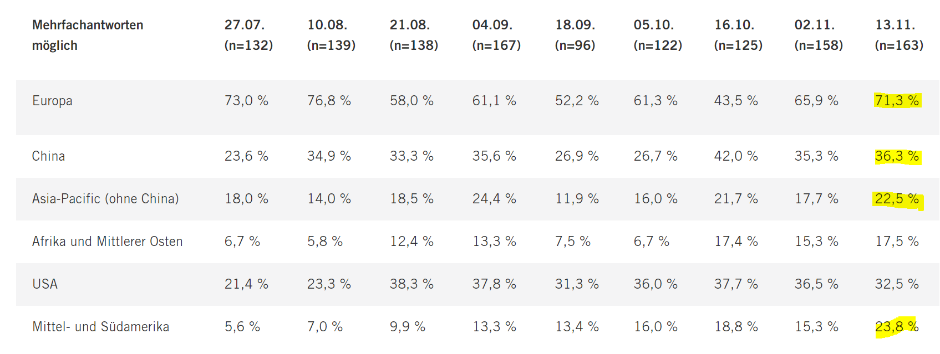

- TMC’s: travel agents are working mainly in short time work and from home, which might get extended until end of August. Webinars and calls are almost impossible.
Lay Offs already started before the summer season; for autumn and winter time a further wave of lay offs happened

In regards to upcoming RFP processes, 25% of the accounts requested a rate extension until end of 2021.
Additionally due to the economic recession because of Covid 19, many companies are in turbulences and will definitely try to reduce the number of accepted hotels to a minimum and to negotiate the rates to a minimum

- Expectations / Trends for 2021-2022 RFP process:
- Very high consolidation and focusing on top volume hotels (50% consolidation compared to LY)
- Corporate Room Night Volume will be copied from 2019, but for 2021 only 50% or lower of the volume can be expected
- Lower rates are highly expected: please try to keep the rate as best as possible, but include more valuable amenities
- Destination shopping up from 1,000 Room Nights
- Stronger outsourcing of Hotel RFP management and Volume Analyzing. Top Supplier for 2021: HRS Sourcing, Advito (BCD), CWT Consulting, American Express, Ratefinding (DER)
- TOP RFP Tools 2021: LANYON, RATEFINDING (compatible to Lanyon) and HRS eRFP
- Less than 50% of Travel Managers in central Europe are interested in including local counter signed agreements into the global hotel program
- Hybrid rates are becoming interesting for a few corporate accounts

- Top Cities in general in Q4 2020: Berlin, Munich, Cologne, Hamburg, Düsseldorf, Stuttgart, Frankfurt, London, Amsterdam, Brussels

- Top Cities expected in general after Covid 19 (2021) : Berlin, Munich, Cologne, Hamburg, Düsseldorf, Zurich, Shanghai, Beijing, Dubai, Hong Kong, Singapore, New York, London, Amsterdam, Brussels

Contact for this market all based in Munich, Germany
Stephan Brauer (Leisure | Corporate) SBrauer@preferredhotels.com

Russia, CIS, Ukraine, Baltics

Corporate/ MICE/group travel:
- According to the recent research 90% of events and conferences were held in Russia in Q1 2021. Around 5% of the incentive trips were held in Turkey and UAE, all MICE players noted a significant increase of hotel rates and conference offers in UAR and Turkey due to the limited number of MICE destinations available for travel with no travel bans or restrictions. They expect a seasonal decline of MICE activities and corporate travel in 2019, however the market will pick up to 75% of the travel volumes in 2019. Current MICE requests are for Egypt, Turkey, UAE, Greece, however the inbound MICE will be the dominating one through the of the year. Among the corporate industries interested in bringing the events abroad are the pharmaceutical, FMCG, and IT.
- Almost 80% of offices returned back to normal work with most of the staff working in the offices, however non-essential travel is still limited, and live conferences are limited to 50-100 participants.
- There is the increasing interest towards corporate dynamic rates and agreements however most of the corporate clients in Russia prefer to settle the payment by the corporate credit card of company upon the moment of booking the hotel, not by the employees directly upon the check in at the hotel.

Contact for the markets of Russia, CIS, Ukraine, Baltics is Elvira Tarasenko, Director of Global Sales: etarasenko@preferredhotels.com

